Optical Properties of Materials – OSE 5312, Summer 2002

Monday, June 17, 2002

Optical Activity

In some isotropic media, (e.g. sugar solution in water) it is found that the polarization of linearly polarized light is rotated in proportion to the propagation distance.

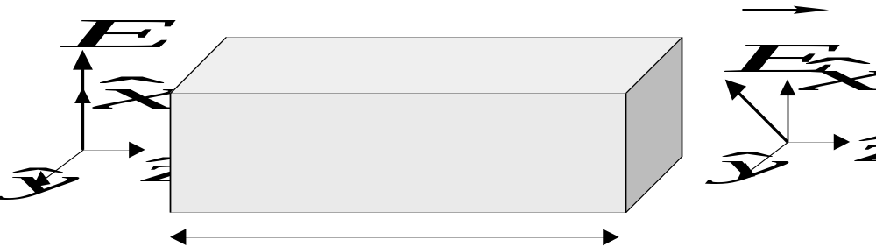

i.e. 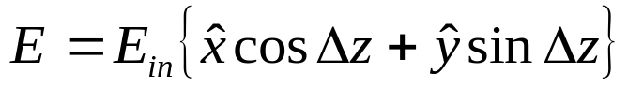,

where Δ is the rotatory coefficient (°/m or rad/m).

This effect is caused by optically induced magnetic dipoles. - Here, we need to consider the 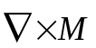 contribution to the current.

Recall, 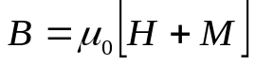, and:
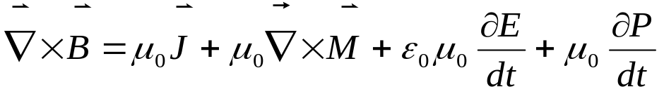

and
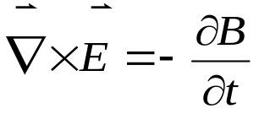,

so that
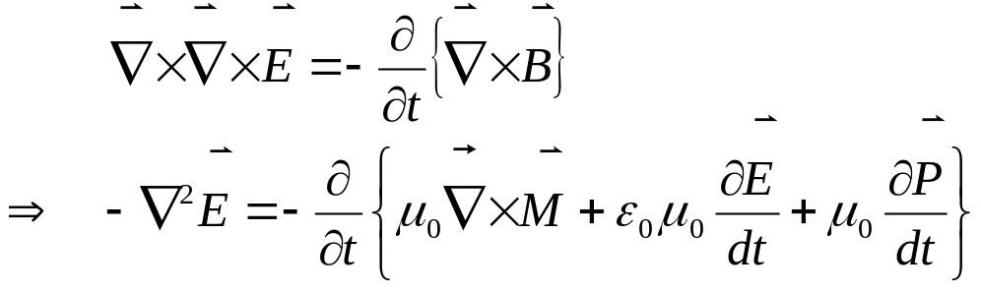

for isotropic media and J_{f} = 0. Hence.

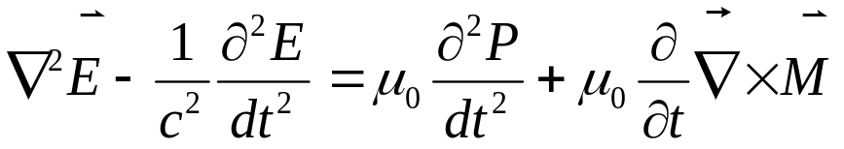

So there is a term due to the curl of the magnetization that looks like a contribution to the polarization. Taking the Fourier transform, we get:

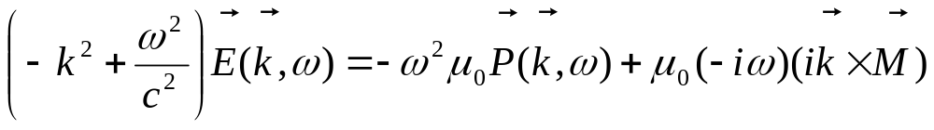

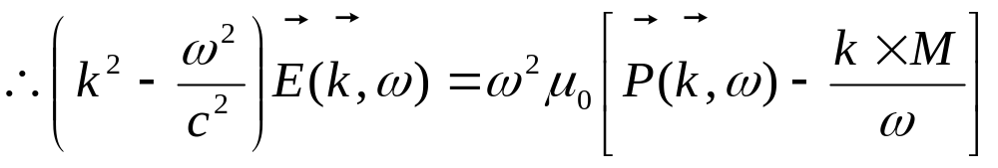

now we can compare magnitudes on the right hand side:

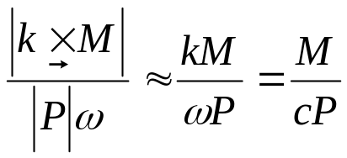

In most cases, this ratio << 1 (see homework), so that if 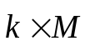 is parallel or antiparallel to P, we can ignore it. This corresponds to M being parallel to B, as shown below. This case is not interesting, as 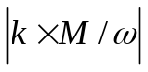 is very small compared to P. (Note that we have assumed isotropic media, so that E and P are always parallel.)
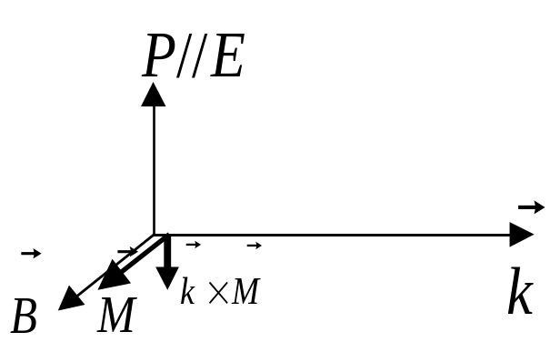

However, if M is parallel to P, then is perpendicular to P, as shown below:
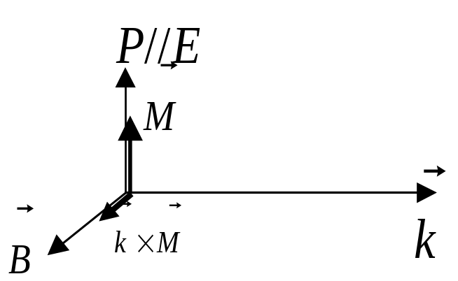

Hence the effective polarization, 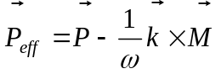, has a small component perpendicular to the applied field. This is what leads to the rotation of the electric field.

Before we examine the mathematics of propagation that describes the rotation, we should ask what kind of material gives rise to a magnetization along the direction of P and hence perpendicular to B.

A simple picture that we can readily come up with is that of a helical molecule, in which electrons are free to move along the helical backbone of the molecule:
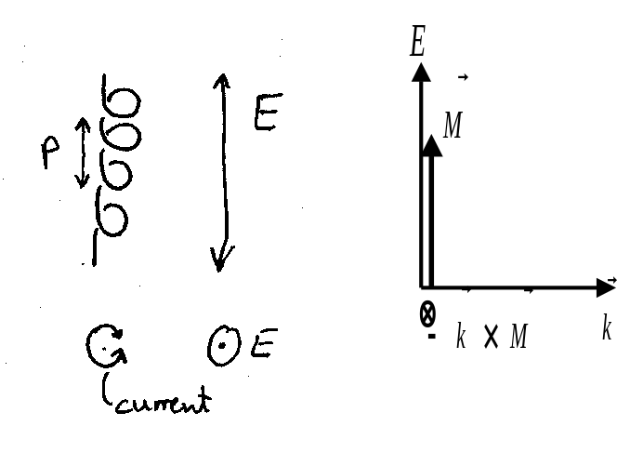
Clearly in a helical molecule of this type, a time-varying induced polarization will result in a circular current that in turn gives a component of magnetization along the axis of the helix. (The molecule behaves exactly like a simple solenoid.) Note if the molecule were flipped by 180°, the effect would be the same. Therefore the effect does not average to zero in an isotropic medium.

Of course, only a limited subset of molecules look like a helix, but in fact any chiral molecule will produce the same effect. Chirality is well defined under Lord Kelvin’s original definition:

Kelvin's definition of chirality
"I call any geometrical figure, or group of points, chiral, and say it has chirality, if its image in a plane mirror, ideally realized, cannot be brought to coincide with itself."
Clearly helical molecules fall into this category, but so do simpler molecules. The simplest example is given below:

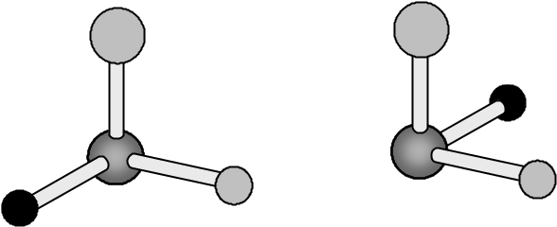
“Left handed”
“Right handed”

For each chiral molecule there exists a left-handed and a right-handed isomer. These special isomers are called enantiomers. While they are chemically identical, they will interact differently with left and right handed enantiomers of other molecules. This is particularly important in biology. For example, orange peel and lemon peel contain opposite enantiomers of the molecule limonene. These are responsible for the smell of the fruit.

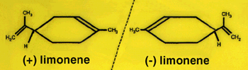
Orange Lemon

Common table sugar is sucrose, which is a combination of glucose (dextrose - right-handed sugar) and fructose (levulose - left-handed sugar). The dextrose molecule is shown below:
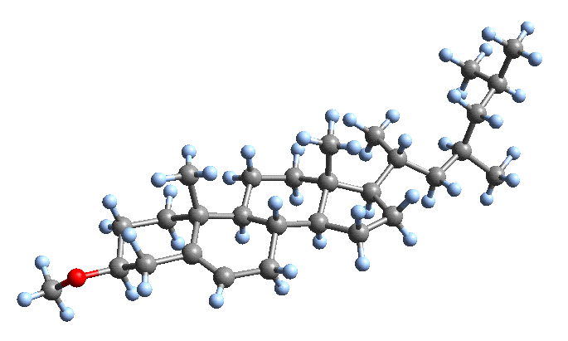

Propagation equations:
Now 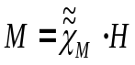, where 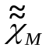 is the magnetic susceptibility tensor.
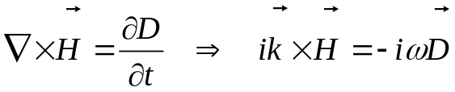 ,
and since the medium is isotropic,
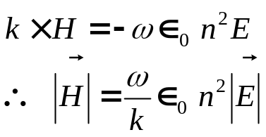.
Since 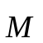 is parallel to 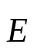, we may treat it as a scalar when relating M and E. Hence we may write χ_{M} as a scalar:
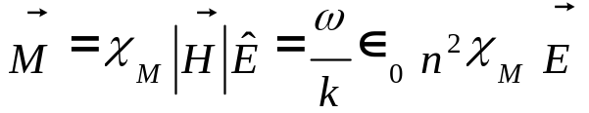
Hence: 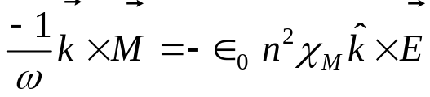
- we will take the direction of k as z. Hence we will write 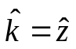.

The wave equation therefore becomes:

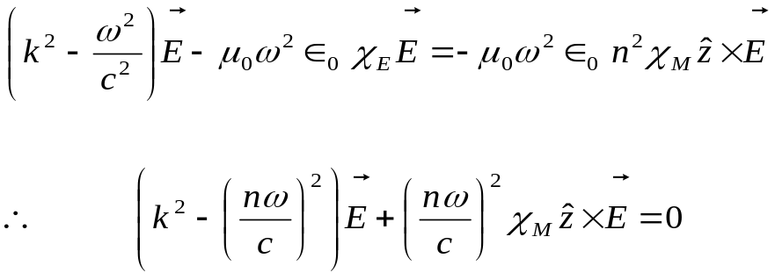

Now, 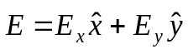, so that
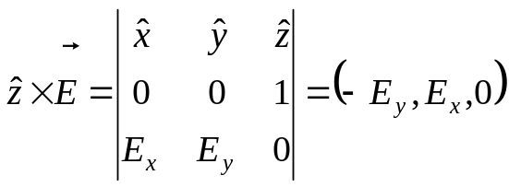
Equating x and y components of the wave equation gives:
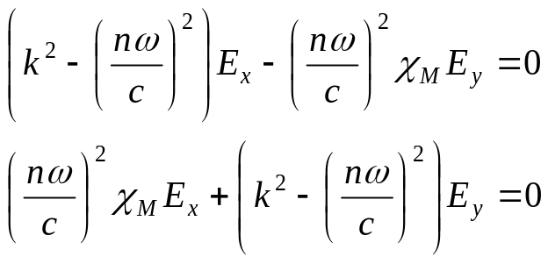

So for a nontrivial solution, the determinant must be zero:

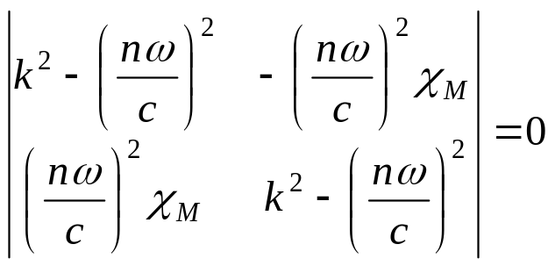

Hence for an eigenmode of the wave equation we have:

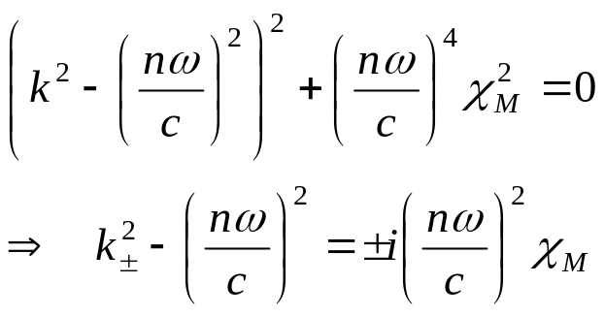

But recall that

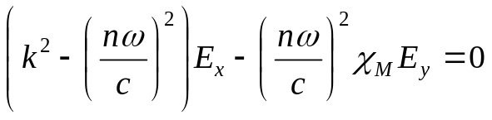,
so that plane wave modes k± satisfy:
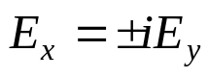
Hence an eigenmode of an isotropic chiral medium is one where e_{x} and E_{y} are equal and π/2 out of phase. – i.e. circular polarization. So we can write the eigenmode as
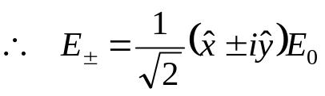,

where E₀ is the field amplitude. These modes have wavevectors:

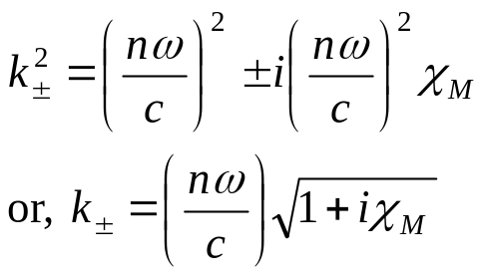
but χ_{M} << 1, so,
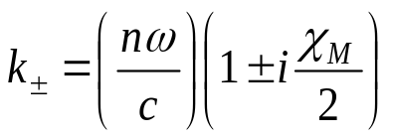.

Hence the RCP and LCP waves experience different refractive indices:
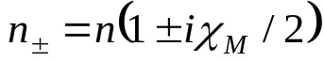.
Now, at this point, it appears that the χ_{M} component of the index is going to give rise to loss, as it appears to give an imaginary component to n. However, we should recall that while the electric polarization is proportional to the displacement, r, of charge, i.e. p ∝ e⋅r, the magnetic polarization is proportional to the current, i.e. 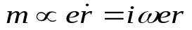. Hence for p real (∴r real), the induced magnetic dipole is purely imaginary. Therefore 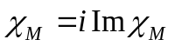 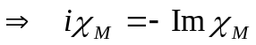. This gives purely real refractive indices:
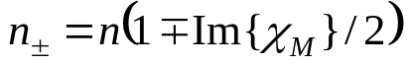
So we now clearly see that the RCP and LCP eigenmodes propagate at different speeds. To deal with linear polarizations, we use the fact that a linearly polarized wave can be written as a sum of equal amplitude RCP and LCP components:
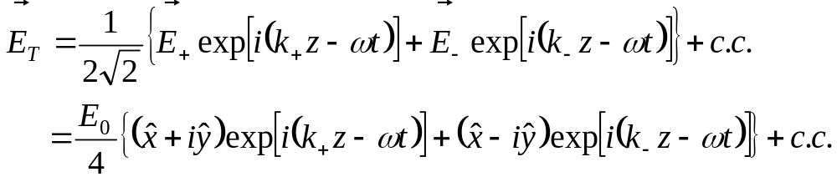

We can simplify by setting 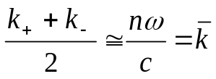, and 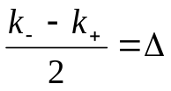. This yields (see homework):

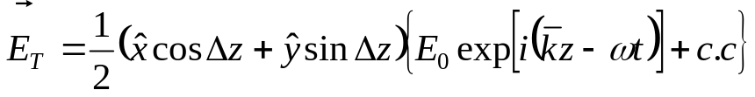

From this, we can see that Δ gives the rotation of the linear polarization per unit length. Hence Δ is termed the “rotatory power”, given by:

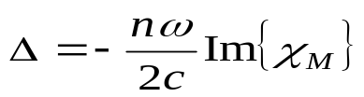 (in °/m or rad/m).

Magneto-Optics

Here we are interested in the effect of an external magnetic field, B, on the optical properties of a medium. (This is somewhat similar to the case of chiral media, except here the “chirality” is imposed by an external magnetic field.)

In general for a medium exposed to an external magnetic field, B:
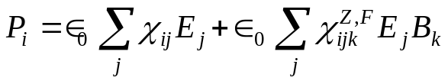 ,
where 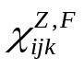describes the linear magneto-optic effects known as the Zeeman and Faraday effects.
Here, we will consider an isotropic material, so that χ_{ij} is scalar. We also let B be oriented along the direction of propagation, i.e. 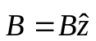. Hence the force on an electron in the medium is given by the Lorentz force law:
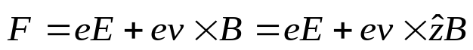.
Now for a general velocity, 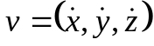 hence, 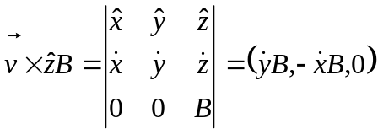.
For a plane wave propagating along z, 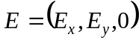, so we have 2 equations of motion for a bound electron in the field:
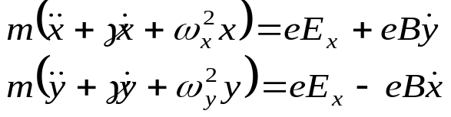
Since the medium is isotropic, then ω_{x} = ω_{y} = ω₀.
Now, a free electron with velocity v perpendicular to a magnetic field will make circular orbits around the z-axis, as shown in the figure below. Hence free electrons in a magnetic field would have a resonant absorption at the “cyclotron” resonance frequency of ω_{c} = eB/m, (also known as the “Larmor Precession frequency). In our case, we have bound electrons, so we might expect that the bound electron resonance is modified by the cyclotron resonance.
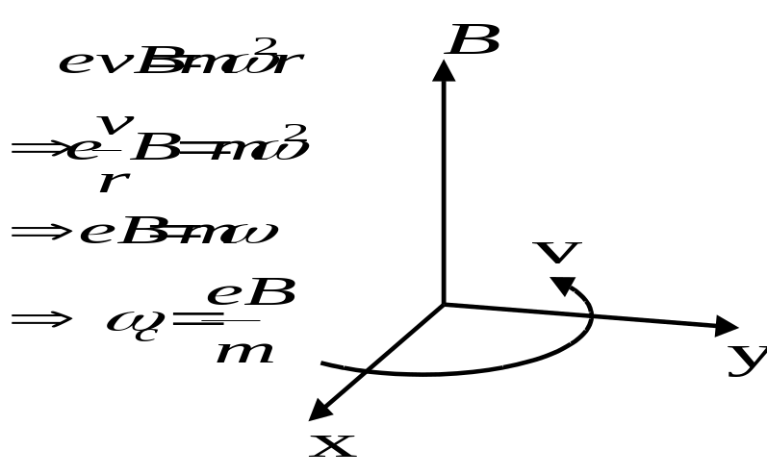
Now, for electric field components defined by:
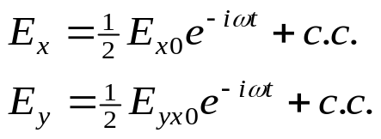,
we anticipate the x and y components of the electron motion to be:
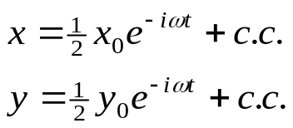
Therefore the equations of motion become:
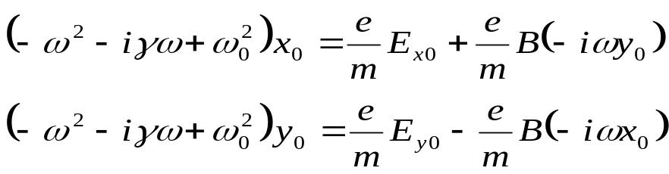
For convenience, we write D(ω) = (ω_{o}² - ω² -iγω), so that:
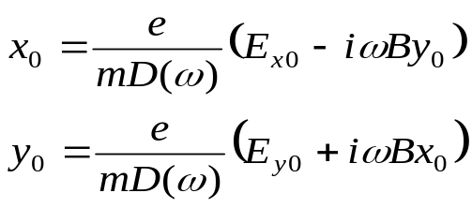.
Anticipating circular motion in our solutions, we define an amplitude, Q, corresponding to such motions:
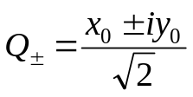
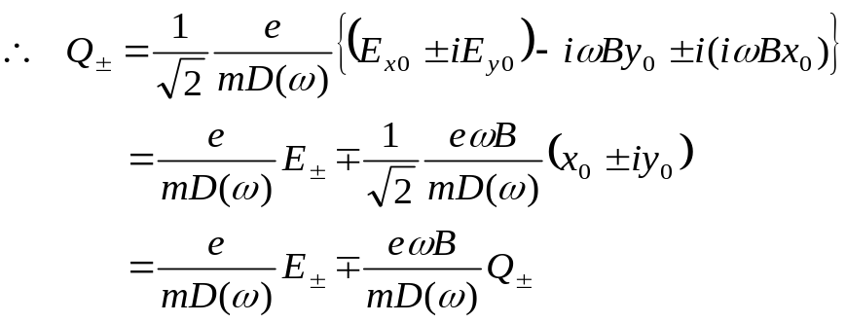
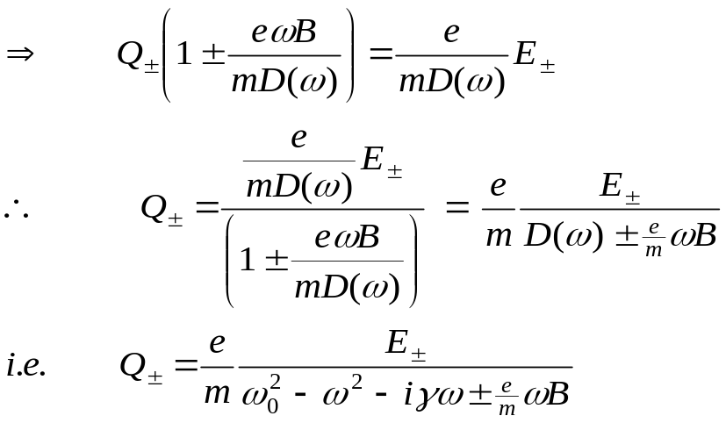
Hence Q± corresponds to the amplitude of electron motion for illumination with right (+) and left (-) circularly polarized light. Note that B = 0 yields the regular result from the Lorentz model.
The resonance frequencies occur for ω₀² - ω² ± ωeB/m = 0, which, under the resonance approximation, becomes 2ω(ω₀ - ω) ± ωeB/m ≅ 0, giving resonance frequencies for the two states of circularly polarized light as:
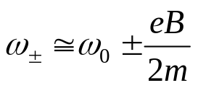
This is known as “Zeeman splitting”

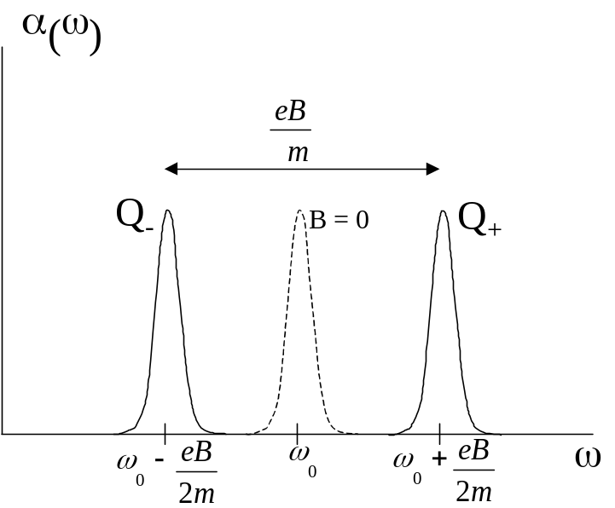

While the Zeeman effect gives the splitting of the absorption lines for left and right circular polarizations due to the magnetic field, the Faraday effect is the rotation of polarization far from resonance due to the consequent slight difference in refractive indices for the two polarization states.

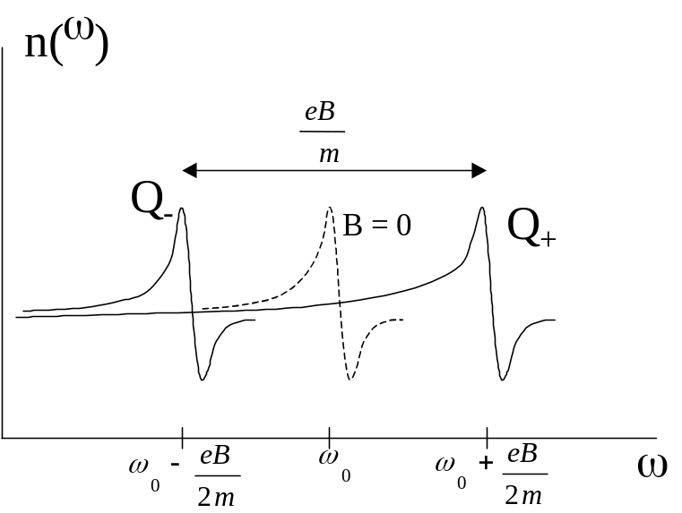

To analyze this, we take the far from resonance approximation:

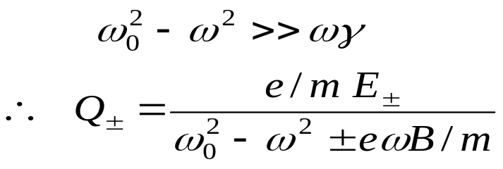

For 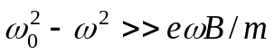, we can expand to first order:

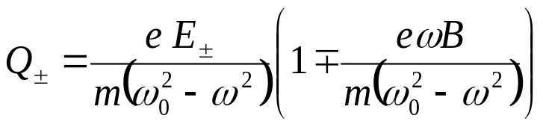

Now, 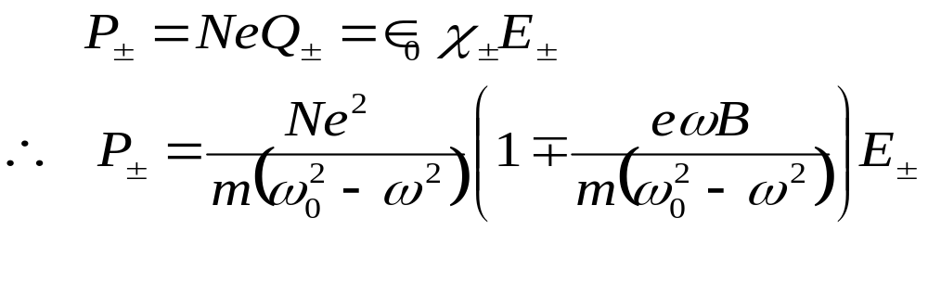
Hence the susceptibility becomes:
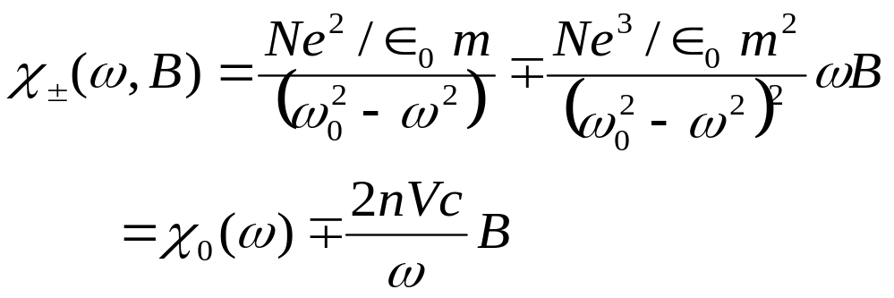
where 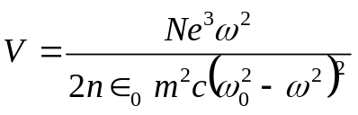 is the Verdet coefficient.
The refractive index for left and right circularly polarized light may hence be written as:
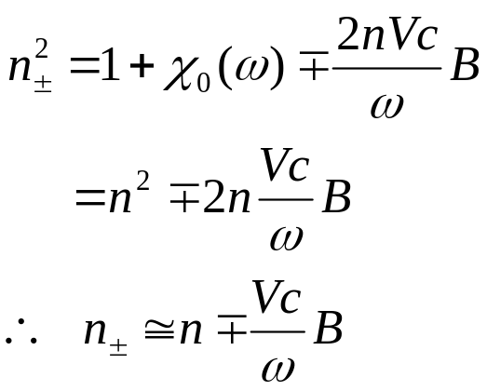

Hence left and right circularly polarized waves see different refractive indices, which again leads to rotation of linear polarization. It is left as a homework exercise to show that, after propagating a distance z, the linear polarization is rotated by an amount VBz. Highly dispersive materials will have large Verdet coefficients. In practice, the magnetic susceptibility will also determine how large a Verdet coefficient of a material will be. – Paramagnetic and diamagnetic materials would actually have Verdet coefficients of different sign.

Note that the sign of B gives the sign of rotation of polarization. Compare this to the case of optical activity where there is no applied field and since the material is isotropic, the sign of rotation is intrinsic to the material, depending only on the sign of χ_{M}.

Faraday Cell:

